Curriculum Vitae

Curriculum Vitae

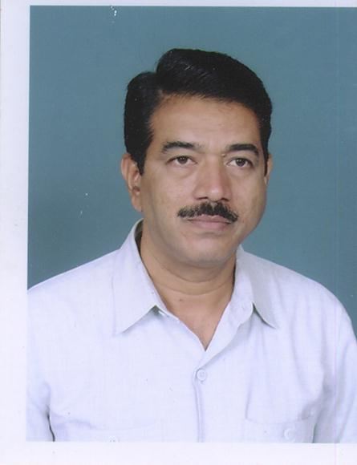
Dr.M.G.Khan is a Professor in the Department of Political Science, Karnatak University, Dharwad. He obtained his B.A.Degree with distinction and also a recipient of Gold Medal from Karnatak Arts College, Dharwad. He received his Masters Degree in first class with II rank to the department in the year 1983. He obtained his M.Phil. degree in flying colours in the year 1984. Khan did his Ph.D degree on the subject “The Party System and Federal Process in India since 1968 in the year 1988. He has put in 27 years of teaching as well as research experience. He started teaching career from Anjuman Arts College, Dharwad in the year 1986 and subsequently joined the PG. Department of Political Science, K.U.Dharwad in the year 1992. He was elevated to the Post of Reader in the year 1997. His area of Specialization is Federal Studies. So far, Dr.Khan has produced ten Ph.Ds and sixteen M.Phils. He has a credit of publishing 25 research papers in national as well as state level journals and one edited book. His works have been cited in research papers and research work. Completed a UGC Research Project, Dr.M.G.Khan attended totally 75 International, National and State level Seminars, Conferences and Workshops. He is associated with various Universities as member of Board of Examiners and Board of Studies, Board of Appointment and KPSC Bangalore, In 1995, Dr.M.G.Khan worked as a Special Officer in Examination section, Karnatak University, Dharwad and as a Special Officer for Minorities and other Backward Classes Cell during 2006-2008. Worked as the Chairman, Department of Political Science, K U D during 2010-12, served as the Chief Coordinator, PG Social Sciences, Examinations Central Valuation June- July 2012. Served as the Chairman and Member of the Local Inquiry Committee.

Address

Dr.M.G.Khan,
Professor,
Department of Political Science,
Karnatak University,
Dharwad. 3

Ph : 0836-2215223
0836-2772215
Mobile : 9902824164
Email:mgkhan24@gmail.com

