Curriculum Vitae

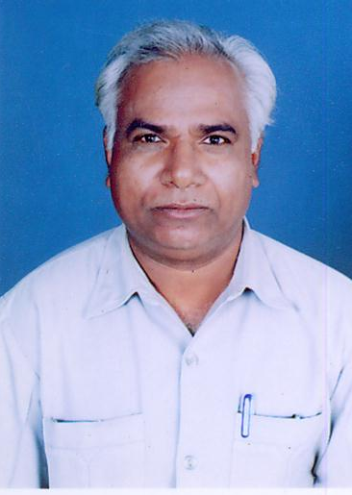
Dr.G.B.Nandana (b 1956) is a Reader in the P.G. Department of Political Science K.U.Dharwad, India. He obtained his Postgraduate degree in Political Science in the year 1987. He received his Ph.D. degree in 1996 on the subject “Central Ideas And Critical Dimensions of Political Philosophy Swamy Vivekananda”. He taught Political Science previously at the G.P.Porwal First Grade College, Sindagi, Dist. Bijapur. There after he joined the P.G. Department of Political Science K.U.Dharwd, as a lecturer in 1997. He was elevated to the position of Reader in the year 1998. Dr. Nandana was nominated as a member of Syndicate and Academic Council by the Government of Karnataka in the year 1999 for 3 years period. At present he is due for promotion as professor. He is author of 4 books, viz., Political Philosophy of Swami Vivekananda 2002, Dr. Ambekdar’s Dalit views 2004, Dr.Ambedkar’s views on Untouchability and Emancipation 2006, and swami Vivekananda and Dr.Ambedkar : Their Political perspectives, 2007. He has published 8 research papers in reputed journals. He has produced 4 Ph.Ds. and 8 M.Phils. He has attended several national and state level seminars workshops and conferences etc. Dr.Nandana has been associated Board of Examiners, Board of Studies, and faculty of Social Science of Karnatak University, Dharwad.

Dr.G.B.Nandana,
Reader,
Department of Political Science,
Karnatak University,
Dharwad. 580003
Karnataka

Ph : 0836-2215223 (O)
0836-2742304 (R)
Cell : 9880859748

