Curriculum Vitae

Dr.N.M.Sali
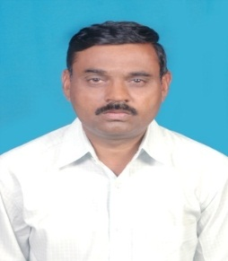
is an Assistant Professor in the Department of Political Science, Karnatak University, Dharwad. He obtained his undergraduate Degree with Second Class from Government College, Hirekerur. He received his Masters Degree in Second class in the department of political science Karnatak University, Dharwad. In the year 1994. He obtained his Ph.D. degree On “The Role of Political and Bureaucratic elites in the Implementation of Rural Development Programmes in the Year 2007. He started teaching career from Sahyadir Arts College, Shivamoga in the year 1998 and joined the PG. Department of Political Science, K.U.Dharwad in the year 2012. His area of Specialization is Decentralized Governance . He has to his credit of published 12 research papers in national as well as state level journals and books. Completed UGC Research Project, Dr.N.M.Sali attended nearly 30 International, National and State level Seminars, Conferences and Workshops. He is associated with various Universities as member and Chairman of Board of Examiners and Board of Studies, and KPSC Bangalore etc,

Address

Dr.N.M.Sali
Assistant Professor,
Department of Political Science,
Karnatak University,
Dharwad. 3

Ph :0836-2215223
Mobile :9480167628
narayanappasali@gmail.com

